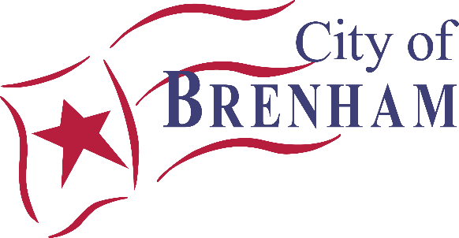
NOTICE OF A MEETING
Animal Shelter Advisory Committee
Tuesday, January 13th
@ 11:00 am
Brenham Animal Shelter
1804 Longwood Drive
Brenham, Texas

- Call Meeting to Order

- Citizen and Visitor Comments

- Introduction of New Board Members

- Discuss and Possibly Act Upon the Election of a Chairperson and Vice Chairperson for 2026

- Discuss and Possibly Act Upon the Minutes from the October 14th, 2025, Regular Meeting

- Discussion and Presentation on the Purpose and Scope of Brenham Animal Services Shelter Statistics for 2025

- Discuss and Possibly Act Upon Meeting Dates for 2026

Adjourn
CERTIFICATION

I certify that a copy of the agenda of items to be considered by the Animal Shelter Advisory Board on Tuesday, January 13th, was posted to the City Hall bulletin board at 200 W. Vulcan, Brenham, TX & on the Animal Services window at 1804 Longwood, Brenham, TX on Wednesday January 7th, 2026, at
11:40 a.m.

Jeana Bellinger, TRMC, CMC
City Secretary

Executive Sessions: The Animal Shelter Advisory Committee may convene in Executive Session to discuss matters authorized by the Texas Government Code, Chapter 551, including but not limited to: §551.071 – Consultation with Attorney, §551.072 – Real Property, §551.073 – Prospective Gifts, §551.074 - Personnel Matters, §551.076 – Security Devices, §551.086 - Utility Competitive Matters, and §551.087 – Economic Development Negotiations. The City Attorney must be present for all Executive Session discussions.

Disability Access Statement: This meeting is wheelchair accessible. Accessible parking spaces are located in the parking lot. Auxiliary aids and services are available upon request (interpreters for the deaf must be requested three business days before the meeting) by calling (979) 337-7567 for assistance.

I certify that this notice and agenda of items to be considered by the Animal Shelter Advisory Committee was removed by me from the City Hall bulletin board & Animal Services window on ____________________ at ___________.

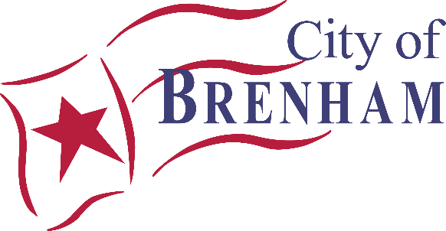

MINUTES

BRENHAM ANIMAL SERVICES ADVISORY BOARD

October 14, 2025

A regular meeting of the City of Brenham’s Animal Services Advisory Board was held on Tuesday, October 14, 2025, beginning at 11:00 a.m. at the Brenham Animal Services Center Conference Room, 1804 Longwood Drive, Brenham, Texas.

Board Members Present:
Megan Gray, Jeana Bellinger, Erin Christian, Carol Doersom, Dr. Christine Rockey, Sharon Guelker

Board Members Absent:
Lori Sladek

City of Brenham Staff Present:
Morgan Patton

Citizens/Others Present:
None

- Call Meeting to Order

- Citizen and Visitor Comments
None were heard.

- Discuss and Possibly Act Upon the Minutes from the July 8th, 2025 Regular Meeting

A motion was made by Carol Doersom and seconded by Sharon Guelker to approve the Minutes from the Brenham Animal Services Advisory Board Special Meeting that occurred on July 8, 2025.

- Discussion and Presentation on the Purpose and Scope of Brenham Animal Services and Shelter Statistics as of September 30th, 2025.

The shelter statistics as of September 30, 2025 were presented by Manager Gray. She included 2023-2024 as well as 2024-2025 statistics as it is the end of the fiscal year. Animal Control Officer responses have increased, which she stated is good because tracking is now more accurate and officers are being more proactive in responding to field calls. Total number of intakes has decreased as well as the overall population at the shelter. There have been fewer reclaims and adoptions this year, which reflects the lower number of intakes throughout the year. Microchip implants for citizens have increased. The number of animals euthanized has decreased by almost half, from 70 to 36 animals. The save rate has increased from 92.6 % to 95.5%. Carol Doersom asked Manager Gray if she is happy with the number of SNAP vouchers given out. Manager Gray stated that she would love to see more interest in the SNAP program, however it is only the first year the program has been implemented and there is hope for a higher response in the upcoming year. Jeana Bellinger stated that she had a meeting with leaders in Washington County and there has been no progress with the county potentially contributing to funding for animals in the county.
Erin Christian stated that she loves how active Brenham Animal Services is on social media, especially the transport stories.

- Administration Updates

Recent Events
- Clear the Shelter- There were 24 adoptions, 6 reservations, 2 reclaims. Manager Gray stated this was very successful with only 1 return.
- Scarecrow Festival-14 adoptions, 2 foster to adopt. This was the most successful Scarecrow Festival adoption event over the past 3 years.
Upcoming Events
- Brazos Valley Gives-ongoing through October 21, 2025. On that date, they will be receiving online donations throughout the day. Manager Gray will be at Brookshire Brothers from 9:00am-10:00am for in-person donations. The funds from this event will go toward community related activities such as transports and the Doggie Day Out program.
- Touch-a-Truck-Chick-fil-A will be hosting this event on October 30, 2025 from 5:00pm-7:00pm. This is to educate the community and children about the services offered by Brenham Animal Services and other City departments while passing out candy.
- Christmas Parade-This event will be held on December 6, 2025. Volunteers and Advisory Board Members are welcome to walk dogs in the parade.
TNR Recap
- Clear the Shelter- There were 24 adoptions, 6 reservations, 2 reclaims. Manager Gray stated this was very successful with only 1 return.
- Scarecrow Festival-14 adoptions, 2 foster to adopt. This was the most successful Scarecrow Festival adoption event over the past 3 years.
- The first TNR event was held on October 8, 2025. The event went smoothly. There were 5 female and 1 male cat brought to the shelter and sterilized before being returned to their original location.
- Carol Doersom stated that StoryBook Rescue is willing to trap cats in the city and TNR them. She gave Manager Gray a flyer for this program. Dr. Rockey stated she could help spay and neuter on her day off if there are a lot of TNR cats all on the same day. Dr. Rockey also stated there are several feral cats behind the movie theater in Brenham.

The next meeting will be 11:00am on January 13, 2026.

Adjourn
The meeting was adjourned at 11:14 a.m.

____________________________________
Megan Gray
Chairman

ATTEST:

____________________________________
Morgan Patton
Staff Liaison

